Batch: T6
Asssignment No: 1
Title of Assignment: Installation, Configuration and Testing of MySQL
Student Name: Harshavardhan Bamane
Student PRN: 22510112

Installation Steps
- Download MySQL Installer and Run the Installer
- Choose setup type ( We can select Custom to manually select components )
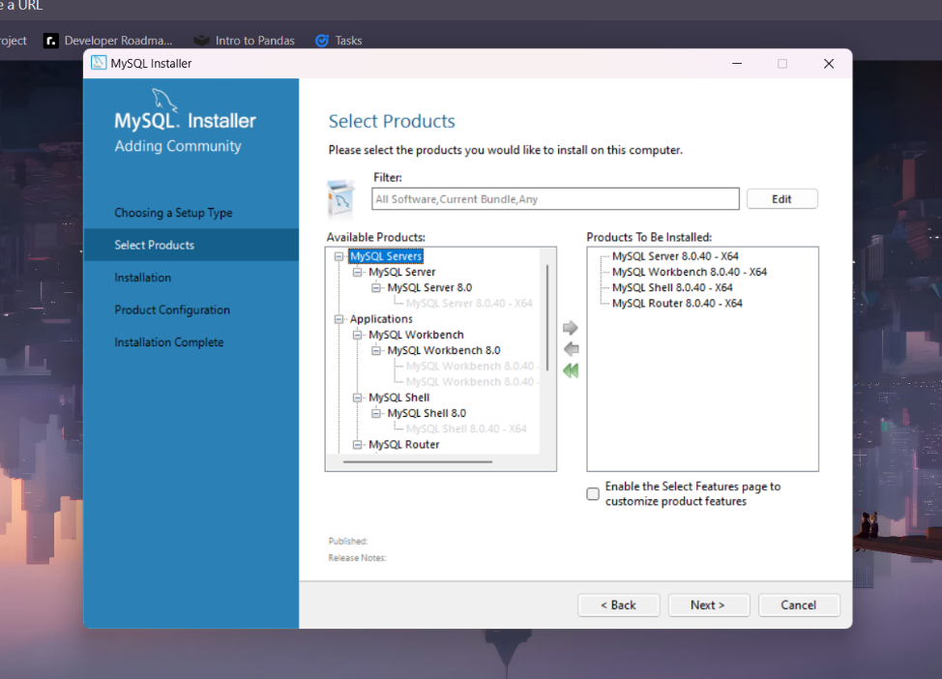
- Install the selected components
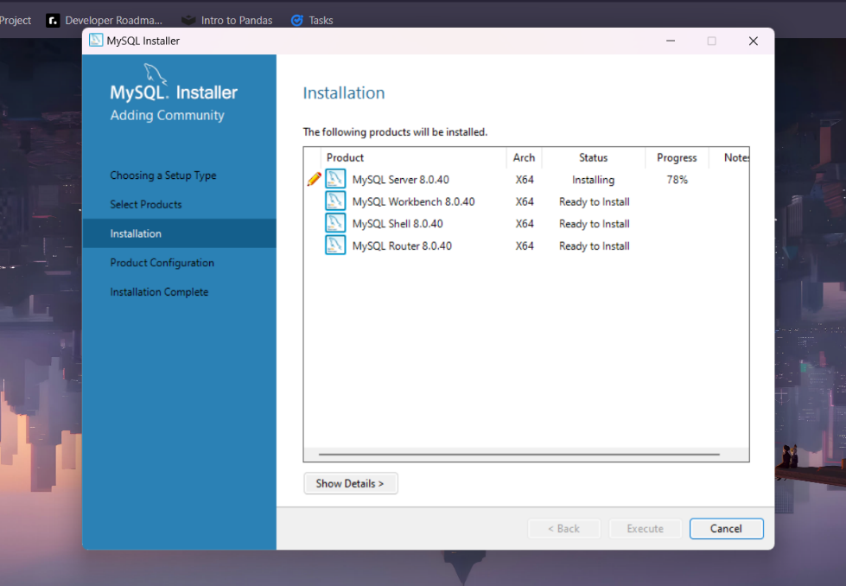
- Configure types and networking
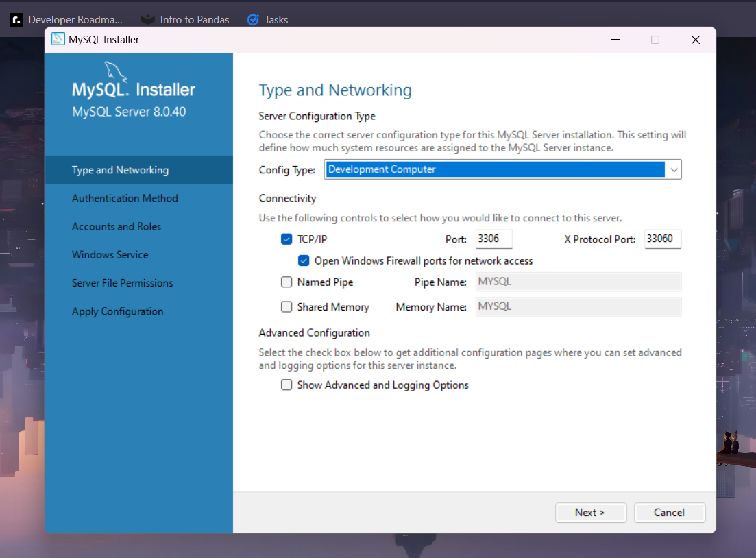
- Apply configuration and finish installation.

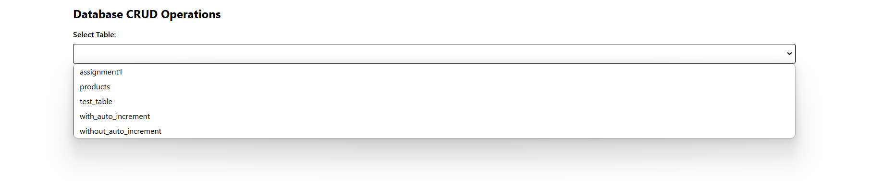

Creating record directly as ID is set auto_increment
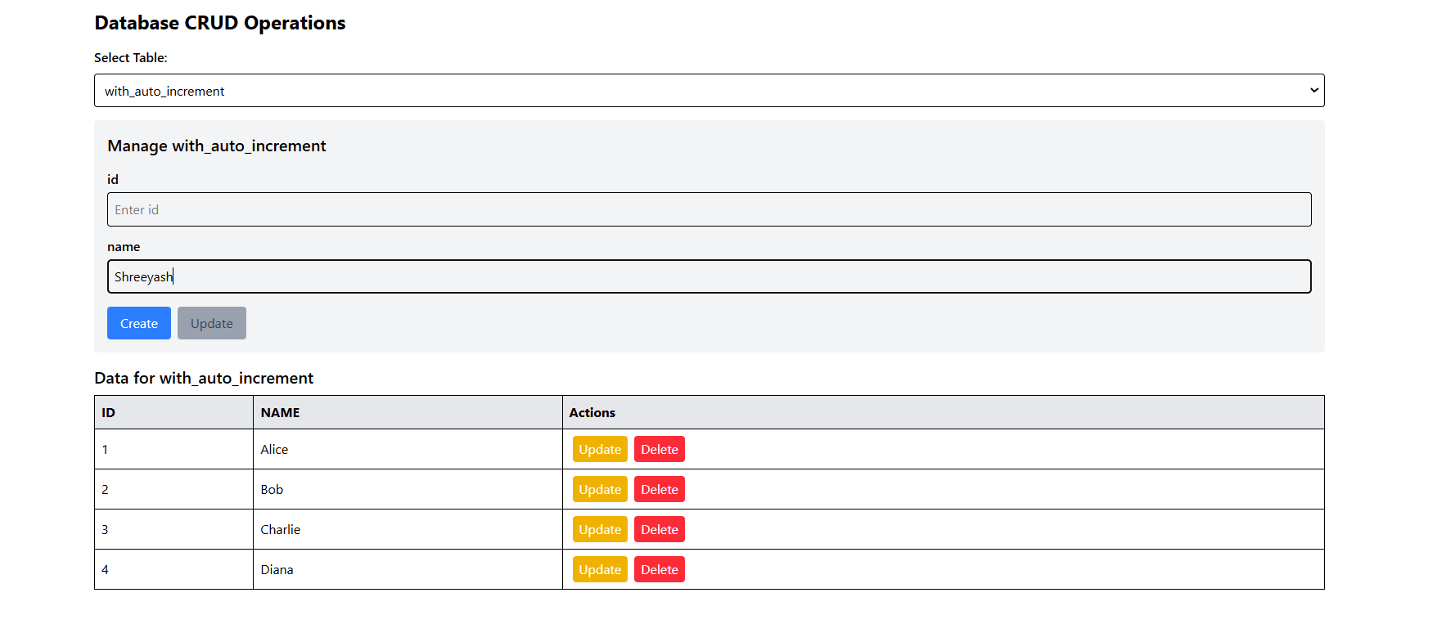

Clicking on update populates values in form
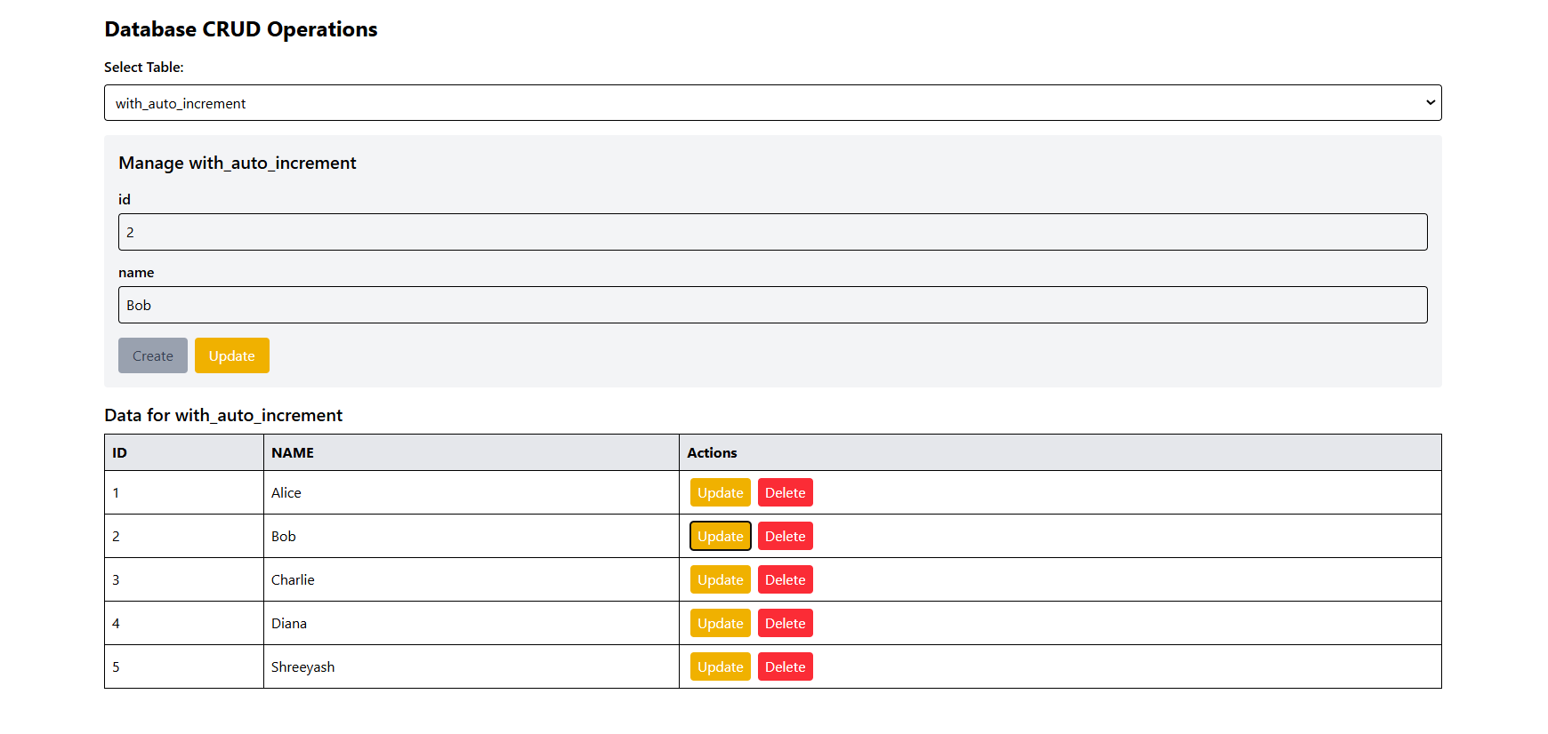
After Update
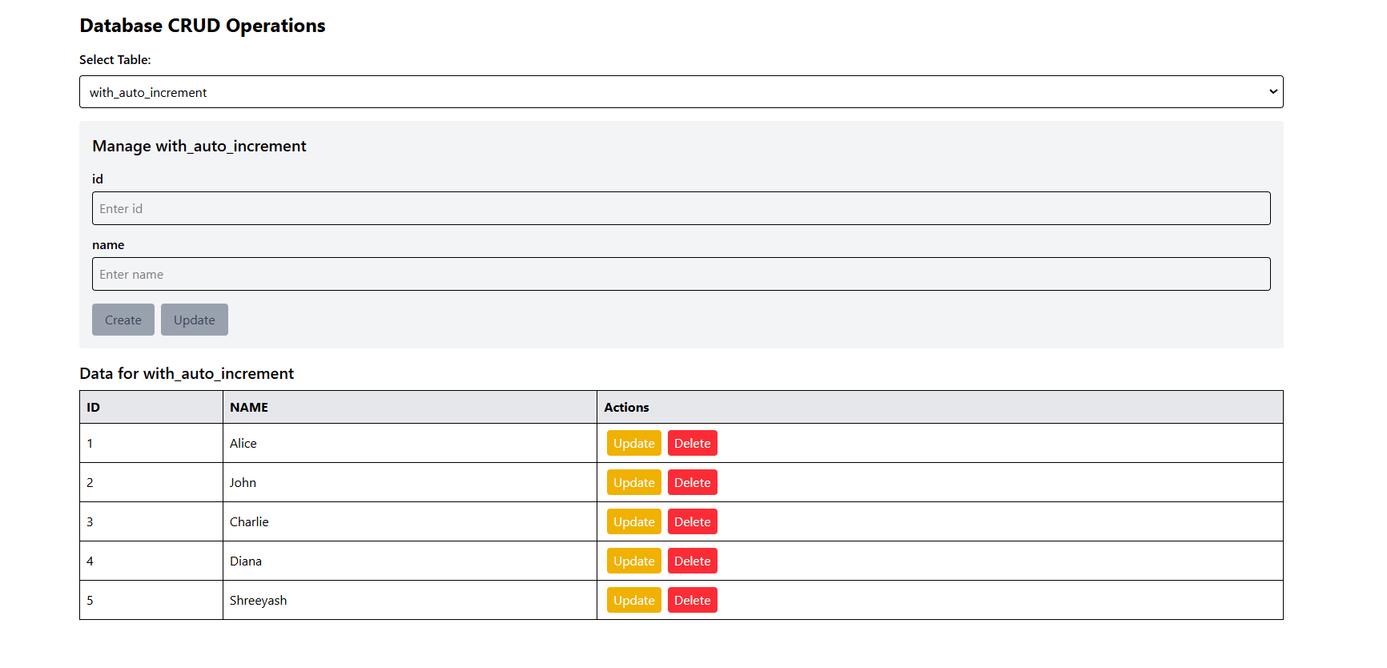

Need to provide ID as constraint is not set to auto_increment
